Our Business is Growing
… and we’d like you to join us!

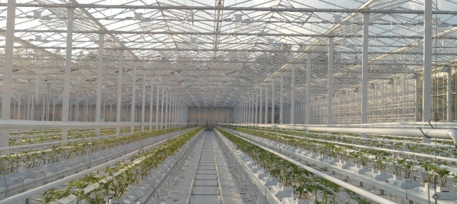
Service Manager Wanted

At Prins Greenhouses we view each job as a fresh challenge. Using innovative technology and a lot of hard work, we are dedicated to designing and building the most efficient growing environments possible for our customers and their crops. Our warehouse serves both our construction teams and our customers who purchase replacement parts directly from us.
Our company is committed to long-lasting relationships with customers, staff and suppliers. It supports the growth of both the individual and the team. With healthy individuals a team is all the stronger, and teamwork is the core of our success.
Are you someone who enjoys stable, challenging and rewarding work with room for growth? Join our team and work with great people who love what they do! Competitive wages, a comprehensive employee benefits plan and RRSP matching are some of the additional perks to working with Prins Greenhouses. Join our team and be part of an industry that brings food to the tables of millions.
Job Overview:

- Act as main point of contact for service calls
- Develop schedules for and oversee the work of service technicians
- Assist clients with technical support
- Preparation of service quotes for customers
- Issue of purchase orders for service department
- Create and close work orders

- Drive the improvement and expansion of the Service Department
- Oversee maintenance schedule of construction equipment

Successful candidates will possess:

- 3-5 years of experience as a technical service department dispatcher
- Previous experience with engineered mechanical systems, or in plumbing/HVAC industries
- Proficiency in use of MS Office Suite and ERP’s
- Ability to provide exceptional customer service
- Ability to work effectively under pressure
- Ability to manage multiple tasks, using strong analytical and organizational skills
- Ability to work independently and collaboratively, with excellent attention to detail
- Excellent verbal and written communication skills, in English
- Valid class 5 driver’s license and reliable vehicle
- Canadian citizenship, permanent resident status or a current work visa

Email your resume and references to hr@prinsgreenhouses.com. Short-listed applicants will be contacted by telephone. Thank you.


