Our Business is Growing
… and we’d like you to join us!

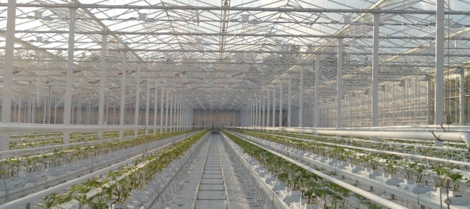
Construction and Installation Team Members Wanted
- Delta, South Surrey, and Fraser Valley
- Full-Time, Monday – Friday, overtime available
At Prins Greenhouses we view each job as a fresh challenge. Using innovative technology and a lot of hard work, we are dedicated to designing and building the most efficient growing environments for our customers and their crops. Our construction and systems installation leaders have over 125 years of combined experience in the greenhouse industry and have been providing high-quality workmanship for growers in Canada and the USA for the last 40 years.
Our company is committed to long-lasting relationships with customers, staff, and suppliers. It supports the growth of both the individual and the team. With healthy individuals a team is all the stronger, and teamwork is the core of our success.
Are you someone who enjoys stable, challenging and rewarding work? Join our team and work with great people who love what they do! Room for growth, competitive wages, a comprehensive employee benefits plan and RRSP matching are some of the additional perks to working with Prins Greenhouses. Join our team and be part of an industry that brings food to the tables of millions.
Job Overview:
- Construction of steel greenhouse superstructure
- Installation of internal systems
- Use of hand and power tools
- Lifting, carrying and distributing construction materials (up to 50 lbs.)
- Operation of aerial lifts and working at heights up to 10 m.
- Outdoor work, all year round

Successful candidates will possess:
- 1 year experience in construction or related labour position, and/or post-secondary education in construction
- Ability to make accurate measurements
- 1 year experience using hand and power tools
- Fluency in English (written and spoken)
- Valid class 5 driver’s license and reliable vehicle
- Canadian citizenship, permanent resident status or a current work visa
Email your resume and references to hr@prinsgreenhouses.com. Short-listed applicants will be contacted by telephone. Thank you.


